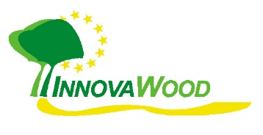
InnovaWood Membership – Application Form

A. Main contact details

Your Organisation
Native Name
English Name
Short Name (Abbreviation)
Address line 1
Address line 2
Address line 3
Street, number
Postcode
City
Country
Web address
VAT number (if applicable)
Main Responsible Contact Person / Representative
First Name
Last Name
Title (Mr, Ms, Dr, Prof. …)
Function (Director, …)
E-Mail
Phone
Main Administrative Contact Person
First Name
Last Name
E-Mail
Area of interest / specialisation (mark with ‘X’)
Research
Development and Innovation
Higher Education
Training / VET
Specify (your main domain):
Type of membership and annual fee (mark with ‘X’)
Full member: 1,000 EUR/year
Special Service Package (SSP): 2,000 EUR/year

B. Staff members of your organisation
These persons will receive the IW Newsletters, e-Alerts and invitations to IW events.

Other Contact persons
No. | Name | Surname | Email address
1
2
3
4
5
6
7
8
9
10
11
12
13
14
15
Note: You can add even more staff members if you wish.

C. Communication Materials
Please send us the following items:
- Your organisation’s logo as image file
- A brief profile of your organisation (e.g. as used in proposals for Horizon 2020 or Erasmus)
- Any general information materials in digital format (brochures, presentations, reports) that are useful to introduce your organisation to the IW members and external stakeholders
- You can also send us some hardcopies to be put on display in the European Forestry House in Brussels.

D. Signature
I herewith confirm as representant on behalf of my organisation to become a member of the InnovaWood network according to the association’s statutes registered in the Moniteur Belge on 27-07-2010. My organisation gives consent that personal data will be processed according to InnovaWood’s Privacy Statement in line with the EU General Data Protection Regulation (GDPR), accessible at our website www.innovawood.com.

Date | Name | Signature
Please return this signed application as scanned version to: secretary@innovawood.com

